Computer networks

**Lab activity – 1 1**

**Name :** N.V.M.Sumanth

**Reg no :** 192111449

**Faculty :** Dr. S. Ramesh

**Course code :** CSA0786 computer networks for wanet applications

**Lab activity :11**

**Question** - **IOT Based Smart Home Using Cisco Packet Tracer**

**Step 1 : Take one router,switch and computer and home devices**

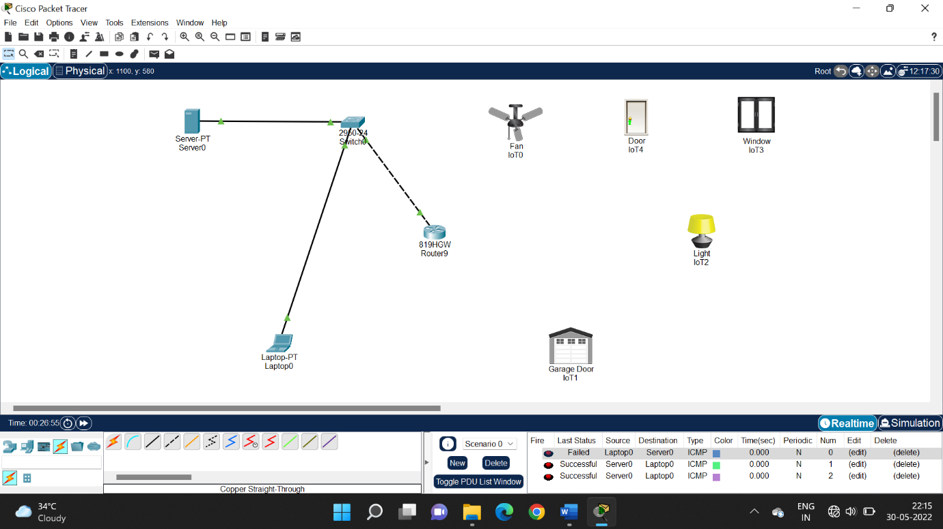

**Step 2 : configure IP address to the server**

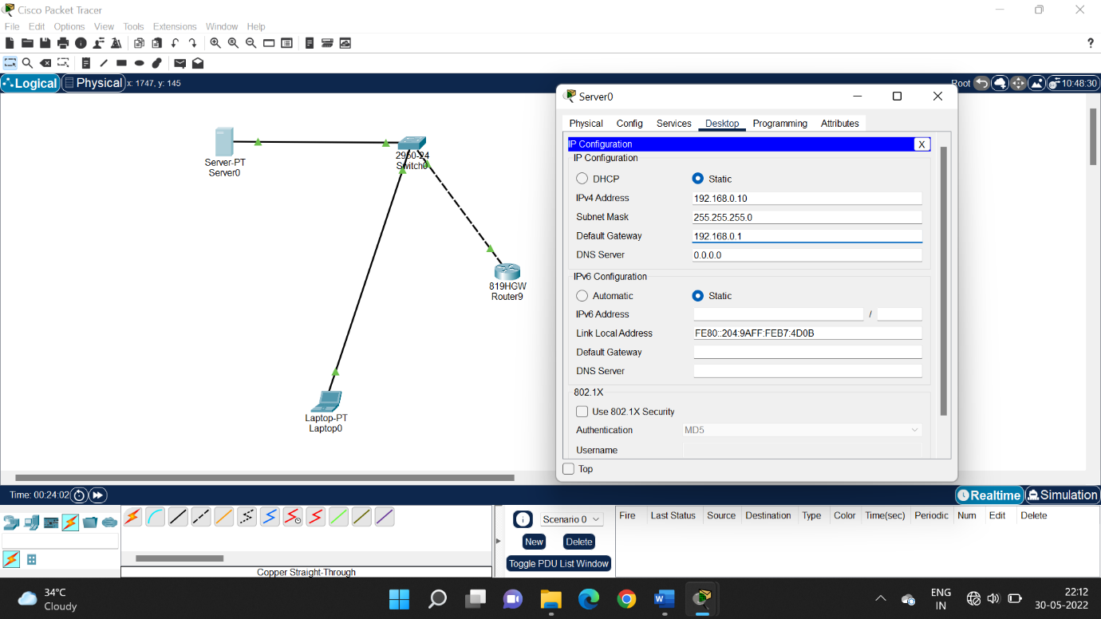

**Step 3 : Go to AAA configuration in server and configure IP address and devices to the server and switch on**

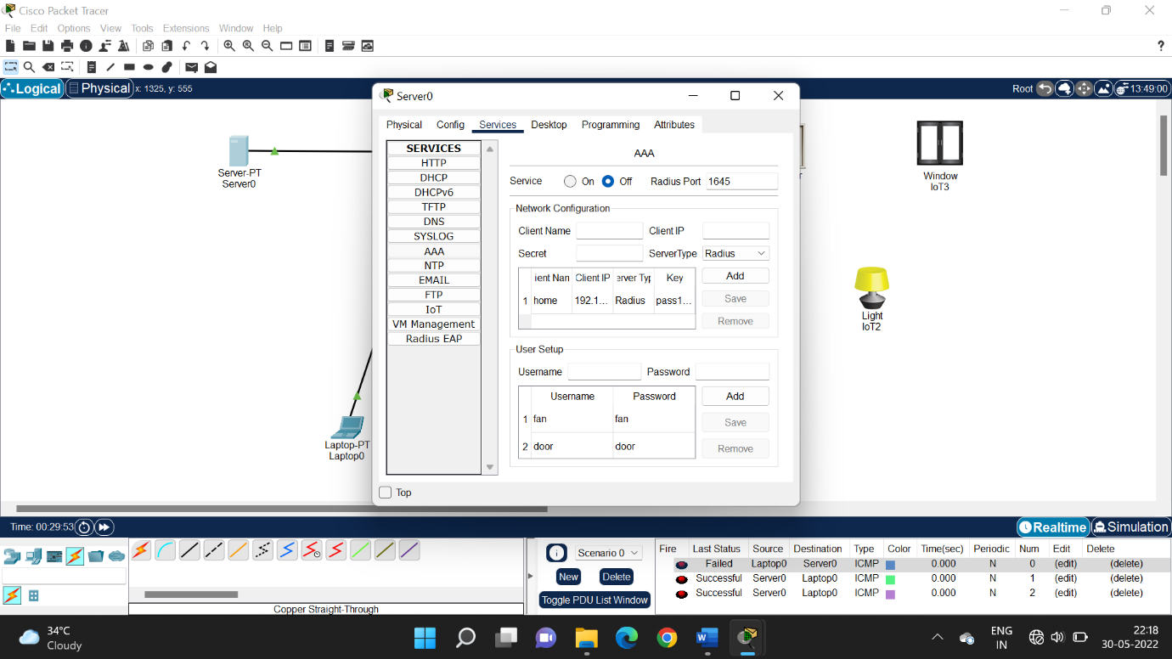

**Step 4 : Go to GUI in server and configure SSID and network mode and save it**

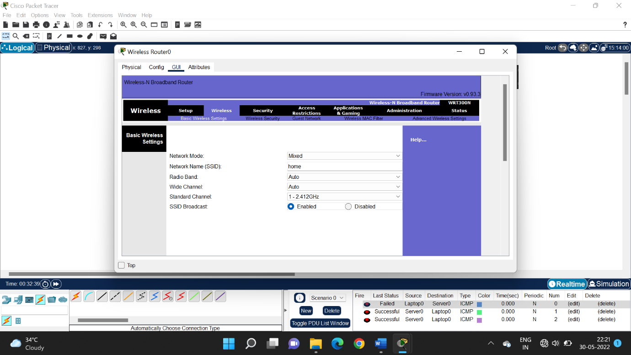

**Step 5 : configure security mode and IP address in wireless security and save it.**

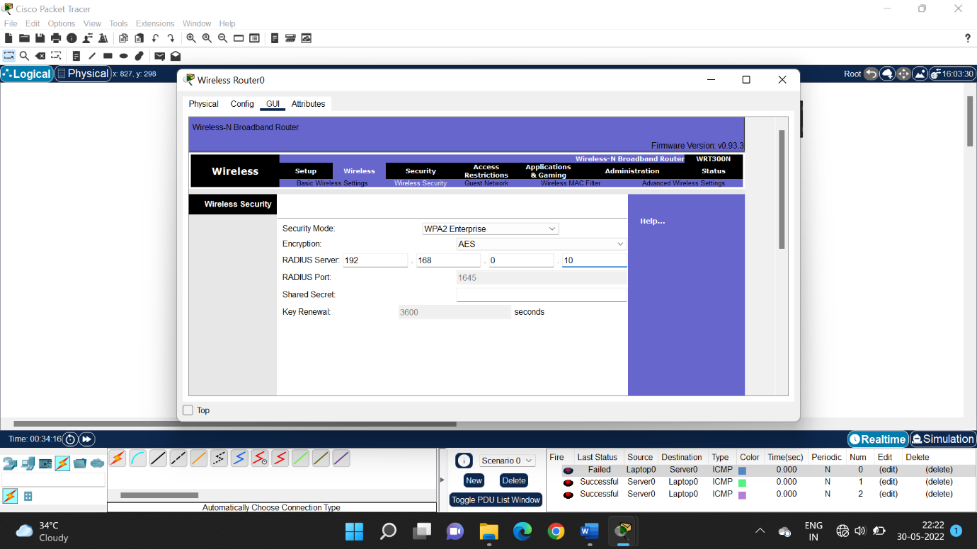

**Step 6 : configure IP address in GUI setup**

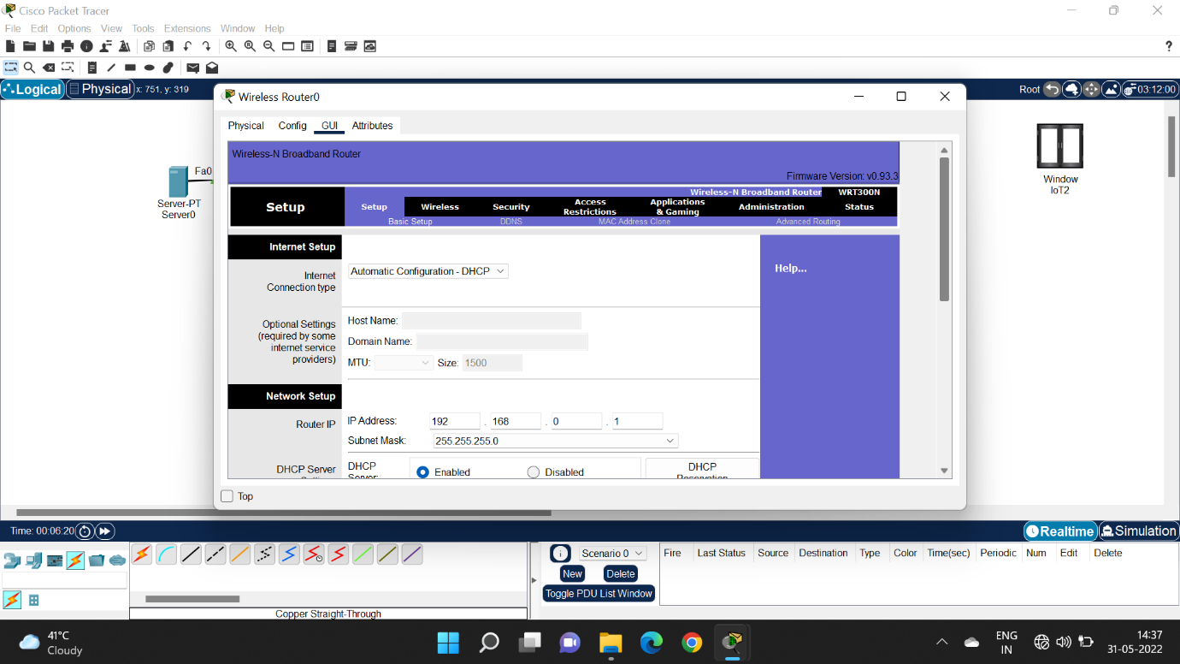

**Step 7 :configure IP address to the server**

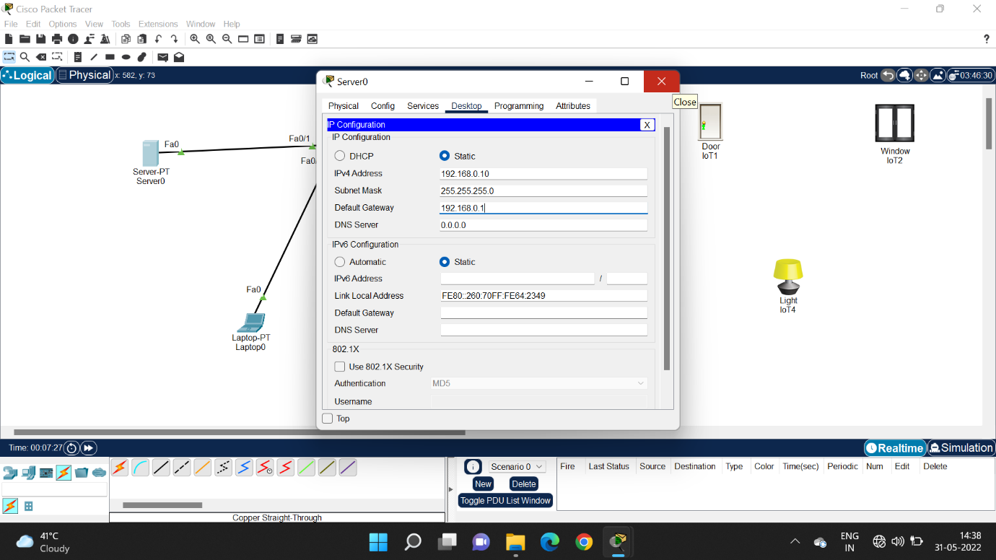

**Step 8 : configure client name and secret code in AAA**

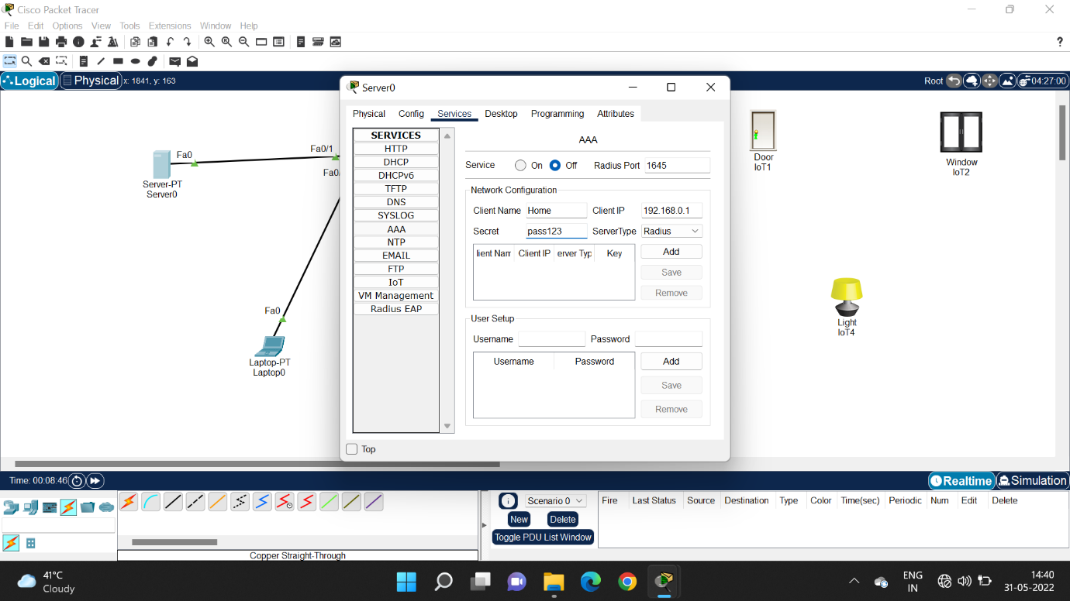

**Step 9 : Go to configuration in home devices select wireless and select wps 2 and configure user ID and password to all the home devices**

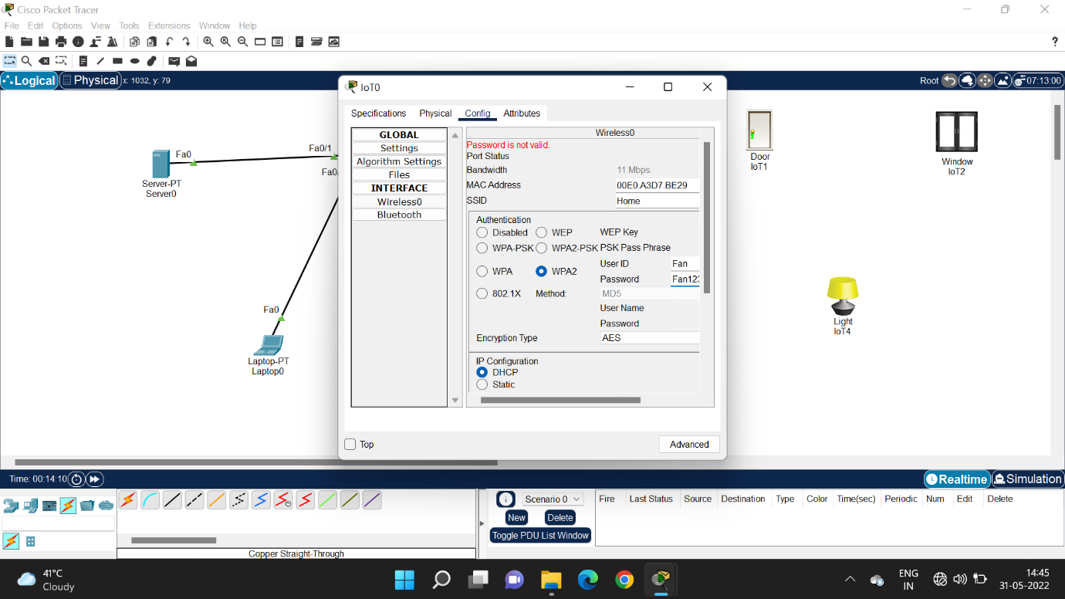

**Step 10 : check the paired devices**

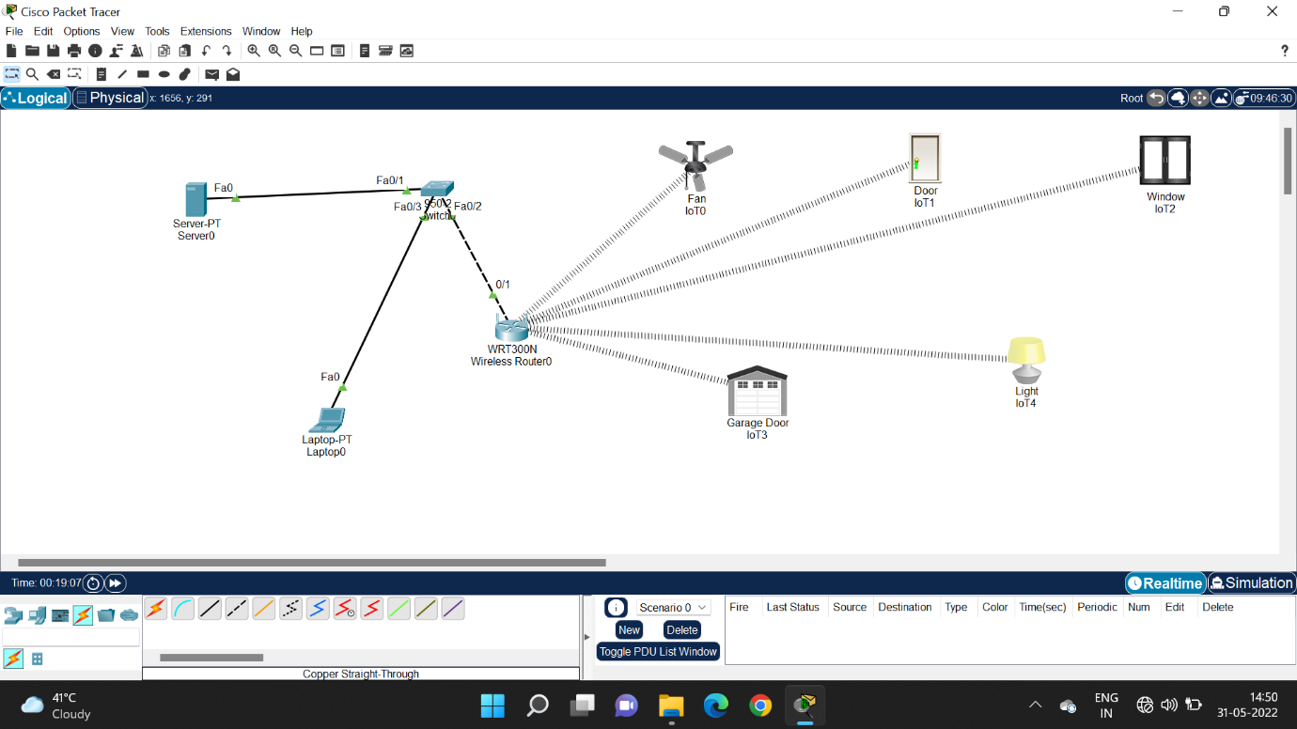

**Step 11 : switch on the registration server**

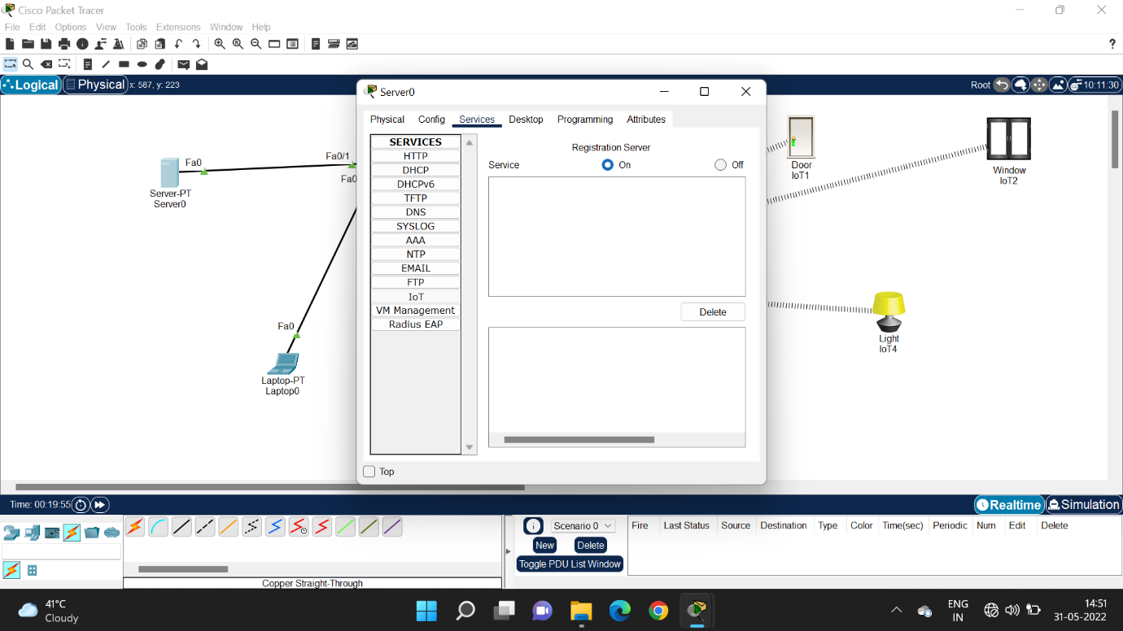

**Step 12 : go to laptop browser and run the Ip address**

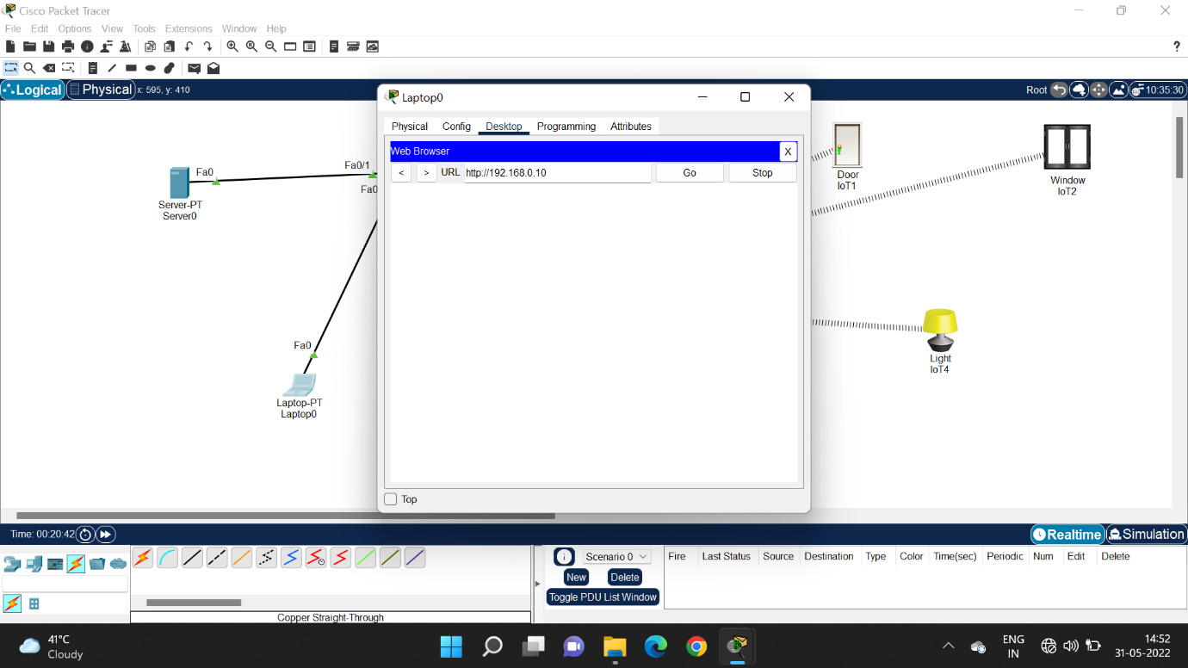

**Step 13 : log in and check the devices connected**

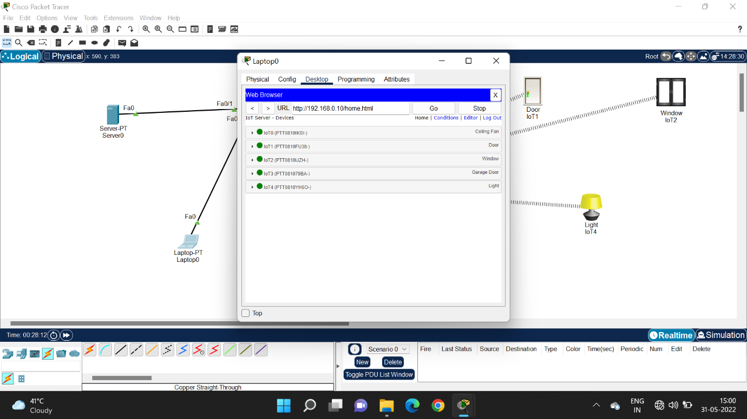

**Step 14 : run the devices using the IOT server**

